The RV-3028-C7 is the first ultra-low power RTC-module requiring just 40nA!

The new Real-time Clock Module RV-3028-C7 sets the new benchmark for lowest power consumption: 40 nA at a supply 3 V. The high accuracy of ±1 ppm at room temperature eliminates any calibration during manufacturing. The tiny package of just 3.5 x 1.5 x 0.8 mm combines the quartz crystal with the RTC circuit, offering also an integrated battery-back-up switch. The extreme low power consumption allows using MLCC capacitors to cover the back-up time. Together with an event detection input it features all the prerequisites for Wearables, Medical Healthcare and power sensitive IoT applications.

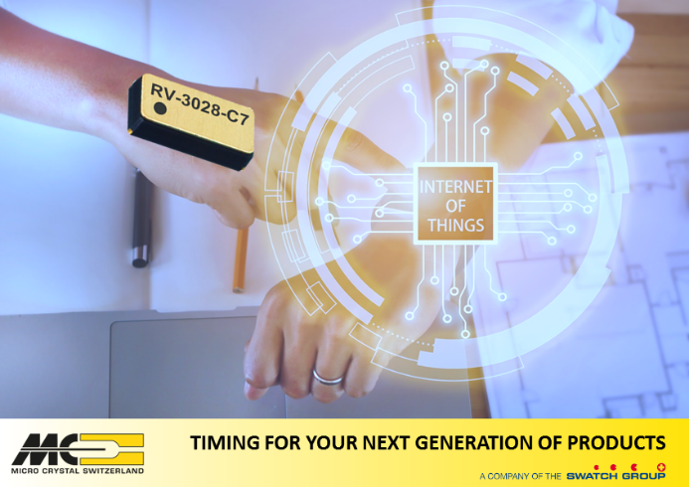
- Industries lowest current consumption of only 40 nA at 3 V supply
- Factory calibrated time reference ±1.0 ppm at 25°C
- Integrated 32.768 kHz Quartz Crystal
- Event input for time-stamping during system power-down
- Battery back-up switch with trickle charge ideal also for MLCC and Supercap
- Wide voltage range 1.2 to 5.5V
- Ultra-miniature ceramic SMD package: 3.2 x 1.5 x 0.8 mm
- Provides year, month, date, weekday, hours, minutes and seconds
- 32 bit Unix time counter e.g. for security code calculations
- I²C interface 400 kHz

Specific link to the home page: http://www.microcrystal.com/index.php/products/real-time-clocks

Quote:
Markus Hintermann, International Product Manager at Micro Crystal AG in Switzerland quotes: “The RTC-Module RV-3028-C7 is the new mile stone in the field of time references. The combination of timing with back-up circuitry featuring the industry’s lowest power consumption extends the autonomy in harsh conditions and will become the time reference of choice for Wearable and IoT applications.”

Micro Crystal, a company of the Swatch Group Switzerland, was founded in 1978 in Grenchen, Switzerland, as a foundry for Tuning Fork Crystals for watches. Today, Micro Crystal is a leading manufacturer of Real-Time-Clock modules, Miniature Tuning Fork and AT-cut Quartz Crystals (32 kHz to 250 MHz), Clock Oscillators and OCXOs for the world’s leading manufacturers of, IoT, wearables, computers, automotive electronics, watches, industrial controls, cellular phones, consumer products as well as medical implantable devices and other high-reliability product applications. With offices located around the globe, Micro Crystal AG provides in-depth support for our customers from design-in to mass production.

  - For further information please contact:

Media inquiries
MarCoMedia GmbH
Monika Ailinger, tel +41 41 850 44 24, m.ailinger@marcomedia.ch

Company contact
Micro Crystal AG
Markus Hintermann, tel +41 32 655 84 91, markus.hintermann@microcrystal.ch

