FOR IMMEDIATE RELEASE CONTACT
Danny Boesing
danny.boesing@samtec.com
812-944-6733

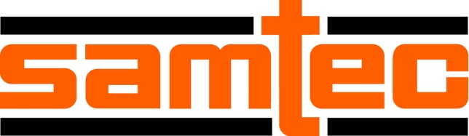 July, 2018

Samtec Ranked #1 in Bishop Customer Survey for 17th Time
Samtec, Inc, a privately held $713 million global manufacturer of a broad line of electronic interconnect solutions, recently received the highest overall rating in the Bishop & Associates’ U.S. Customer Survey of the Electronic Connector Industry. This is the 17th time Samtec has been rated as the #1 connector company in North America.
Samtec received the highest overall ranking in the survey. Samtec was ranked #1 by Engineers, Purchasing, OEMs, CEM/EMS, and Cable Assembly Houses. Samtec also received the top ranking in product quality, meeting requested delivery dates, technical support and expertise, order lead times, on-time delivery, new connector turnaround time, and delivery of samples. Samtec’s website, www.samtec.com, was the highest ranked in overall satisfaction, ease of finding products, availability of technical documentation, and satisfaction with placing orders electronically.
“This demonstrates Samtec’s commitment to service at all levels of their company,” said Ron Bishop, President of Bishop and Associates. “It shows they understand that the definition of service evolves and they change with it. Samtec is the gold standard for quality and overall customer service.”
Bishop & Associates annually surveys electronic equipment manufacturers (OEMs), Cable Assembly Manufacturers, Contract Manufacturers (CEMs) and Distributors to determine how the connector industry, and selected connector manufacturers, are performing.
Respondents represented a variety of market sectors, including Industrial Controls and Production, Medical, Military/Government, Telecom/Datacom, Computer/Peripheral, Automotive, Aircraft/Space/Missiles, and Test/Measurement/Instrumentation, to list the biggest segments.
Forty two (42) connector manufacturers were included in the survey, including Molex, TE Connectivity, Amphenol, 3M Electronics, Phoenix Contact, Hirose Electric, ITT Cannon, J.S.T., ODU, and Kycon, among others.
About Samtec, Inc.: Founded in 1976, Samtec is a privately held, $713 million (USD) global manufacturer of a broad line of electronic interconnect solutions, including High-Speed Board-to-Board, High-Speed Cables, Mid-Board and Panel Optics, Flexible Stacking, Micro/Rugged components and cables, and precision RF. Samtec Technology Centers are dedicated to developing and advancing technologies, strategies and products to optimize both the performance and cost of a system from the bare die to an interface 100 meters away, and all interconnect points in between. With 33 locations in 24 different countries, Samtec’s global presence enables its unmatched customer service. For more information, please visit http://www.samtec.com.
About Bishop and Associates: Bishop and Associates is a market research firm that specializes in the world electronic connector industry. The firm publishes a monthly newsletter titled “The Bishop Report,” and the twice-monthly digital publication Connector Supplier. The reports, produced by a staff of 20 researchers, focus on geographic regions, end-user equipment markets, connector products, and interconnect technologies. The firm also provides executive placement services and conducts multi-client studies and customer surveys, and assists in merger and acquisition activity. For more information, please visit http://bishopinc.com/.
Contacts:
Samtec, Inc.:
Danny Boesing
Product Marketing Director
danny.boesing@samtec.com

Bishop & Associates:
Ron Bishop
President
bishop@bishopinc.com

