For immediate release

Industries Lowest Current Temperature Compensated I²C Real-Time Clock Module from MICRO CRYSTAL

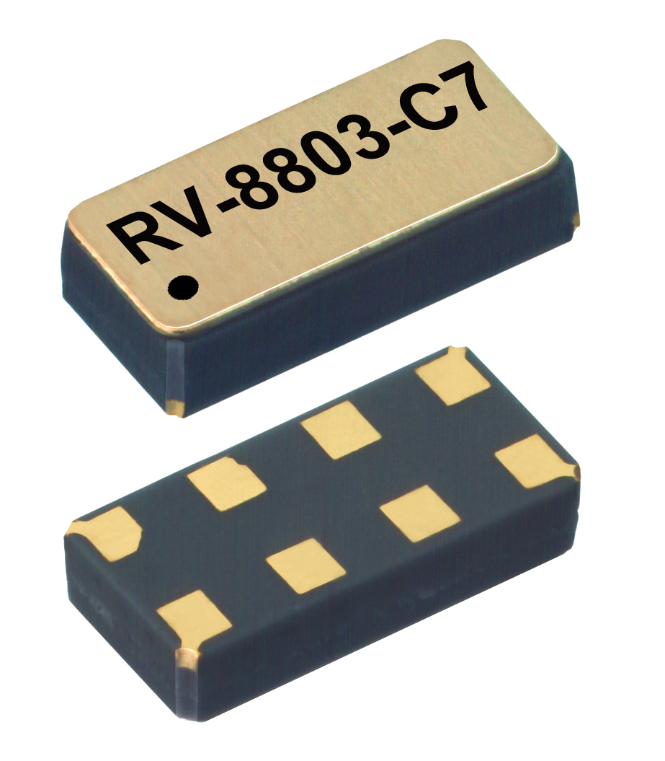

The RV-8803-C7 is the first Temperature Compensated RTC optimized for ultra-low power consumption to replace expensive batteries and super caps with low cost MLCC capacitors for battery backup operation.

Grenchen, Switzerland, 21. April 2015 – The current consumption of 240nA and operation down to 1.5V significantly increases the operational life of backup supplies and allows for potential use of low cost MLCC capacitors as a short term backup solution. All this while providing accuracy of ±3.0 ppm (±0.26 seconds/day) over a temperature range of -40° to +85°C. In addition to the lowest current and best accuracy of all temperature-compensated RTCs, the RV-8803-C7 also has the smallest ceramic package in the industry with an integrated 32.768 KHz quartz crystal.

The RTC’s accurate timekeeping together with reliability of a power failure backup makes it ideal for a wide range of applications such as metering applications, embedded modules, data loggers, white goods, automotive, portable/wearable medical equipment and all types of POS systems.

- Ultra-miniature ceramic SMD package: 3.2 x 1.5 x 0.8 mm
- Integrated 32.768KHz Quartz Crystal
- I²C interface
- low current consumption of only 240nA
- Very high accuracy from -40° to +85°C
- AEC-Q200 qualified

Key technical data
Specification | Value | Unit | Comment
Output frequency | 32.768 | kHz
Frequency tolerance @ 25°C | ±20 | ppm
Accuracy, compensated | ±3.0 | ppm | -40°C - +85°C
Ageing, 1st year max. | ±3 | ppm
Operating temperature range | -40 to +85 | °C
Operating voltage range | 1.5 – 5.5 | Vdd | temperature-compensated
Current consumption | 240 | nA | Vdd = 3.0 V
Package dimensions | 3.2 x 1.5 x 0.8 | mm

This high-performance RTC module sets new standards in size, accuracy and current consumption, while remaining very low-cost, enabling universal use in price-sensitive applications.

About Micro Crystal AG:
Based in Grenchen, Switzerland, Micro Crystal designs, manufactures and sells worldwide quartz crystals, oscillators, OCXOs and real-time clocks for the electronics industry. The company employs approximately 1000 people globally and has high-volume manufacturing facilities in China, Thailand and Switzerland. Micro Crystal’s sales offices in Europe, Asia, Japan and North America ensure close cooperation with customers and excellent technical support. Micro Crystal AG stands for reliable safe technology, high quality and environmentally friendly production. www.microcrystal.com

About Swatch Group Electronic Systems
Micro Crystal is a member of the Swatch Electronics Systems Group (SGES). SGES was founded by Swatch Group electronics subsidiaries to provide the best possible development synergies for customer applications.

----------------------------------------------------------------------------------------------------------------------------------------
For further information, please contact:

Micro Crystal AG
Frau M. Hartmann
Muehlestrasse 14
CH-2540 Grenchen
Tel.: +41-(0)32-655 82 97
Fax: +41-(0)32-655 82 83
sales@microcrystal.com
www.microcrystal.com

